**TRANSACTIONAL WEB APPLICATIONS**

**PROJECT**

**-420-951-VA- SECTION-05813**

#### **DELIVERABLE #** 3

**Implementation**

1. **Implemented Web Application**

Deliver your implemented solution that includes all required features fully functional without bugs. The deliverable should include database scripts, front-end code, and back-end code.

Documentation is on github

GITHUB： <https://github.com/liangjianquan82/ExpenseStatistics.git>

1. **Interface display**

**Url: <http://localhost/ExpenseStatistics/login/>**

**Login page**

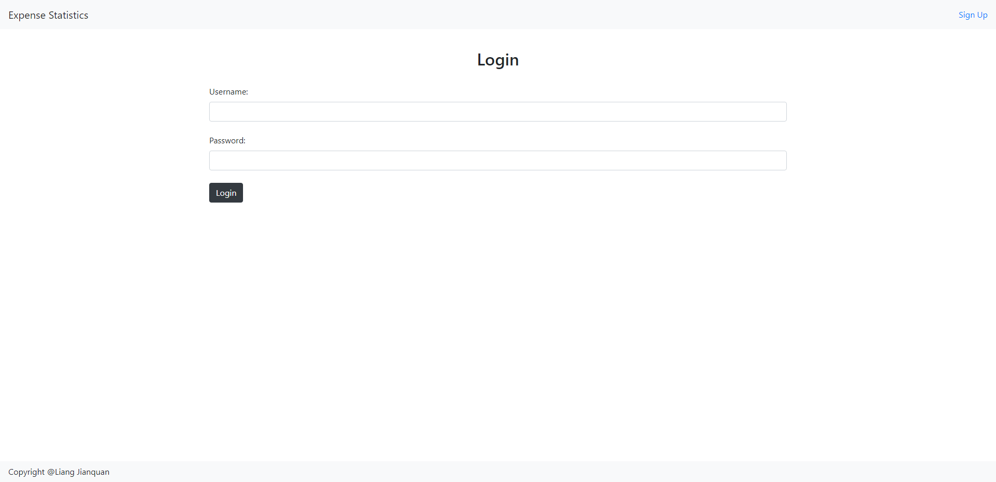

Username: [user1111@gmail.com](mailto:user1111@gmail.com)

Password: 11111

**Home Page**

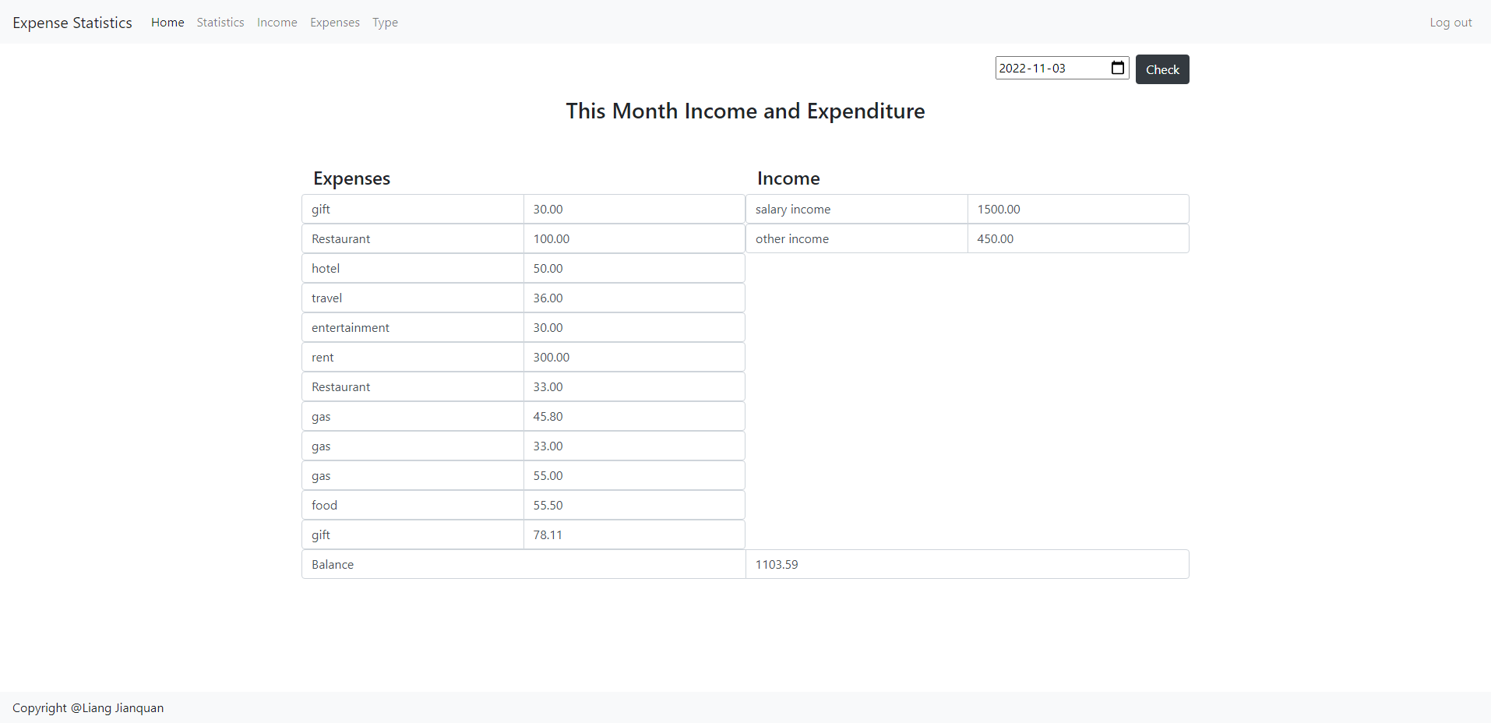

**Income Page**

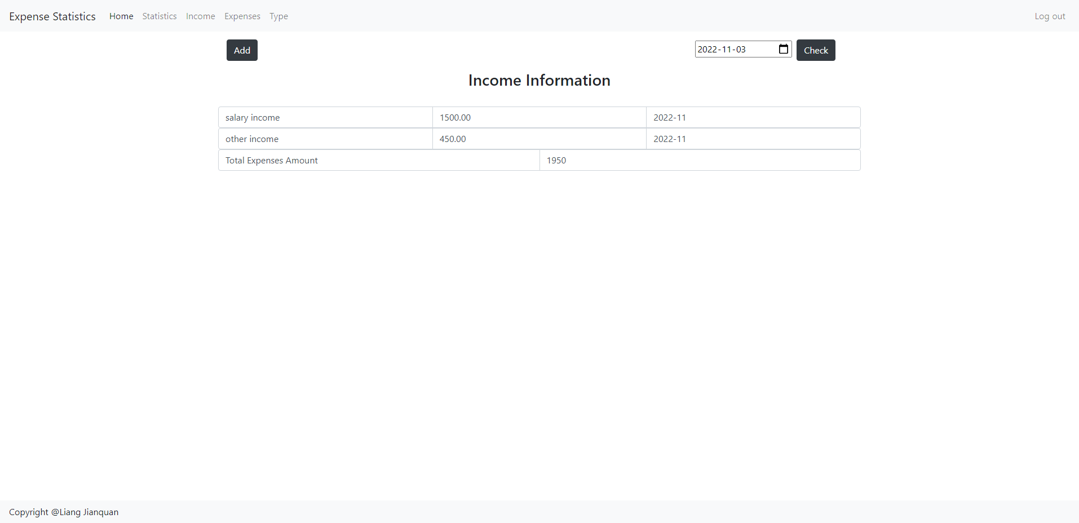

**Expenses Page**

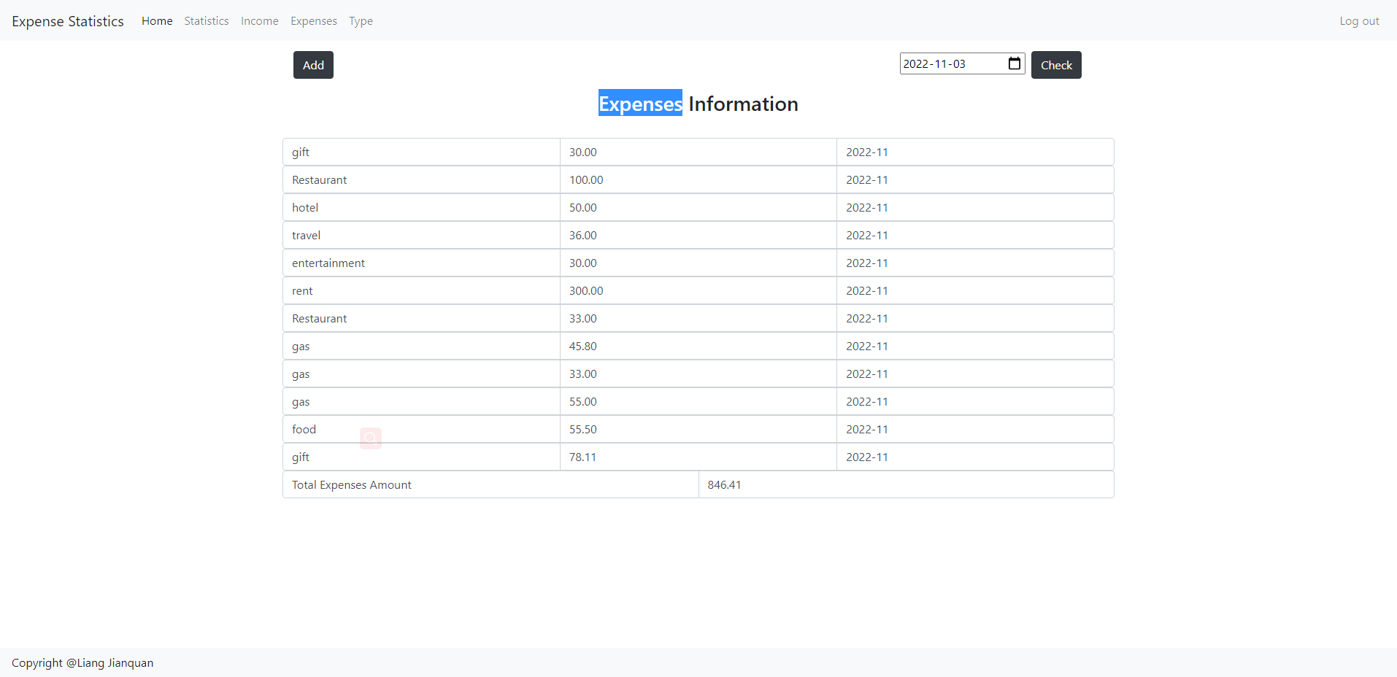

**Add or update Fee**

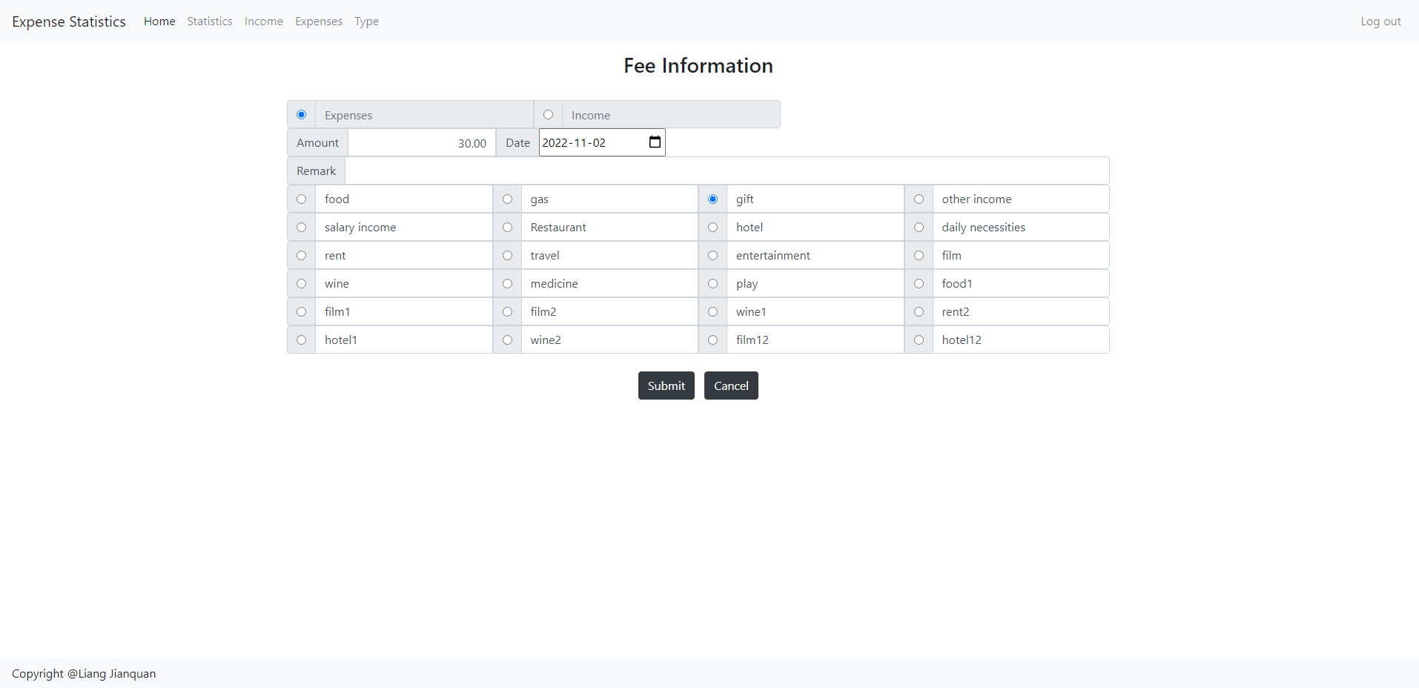

**Type List Pager**

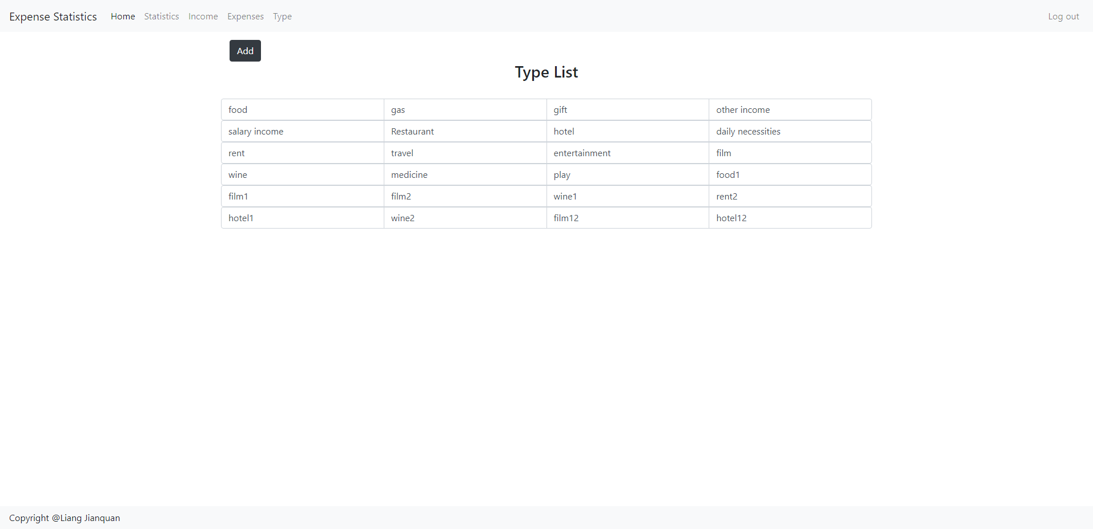

**Add or Update Type**

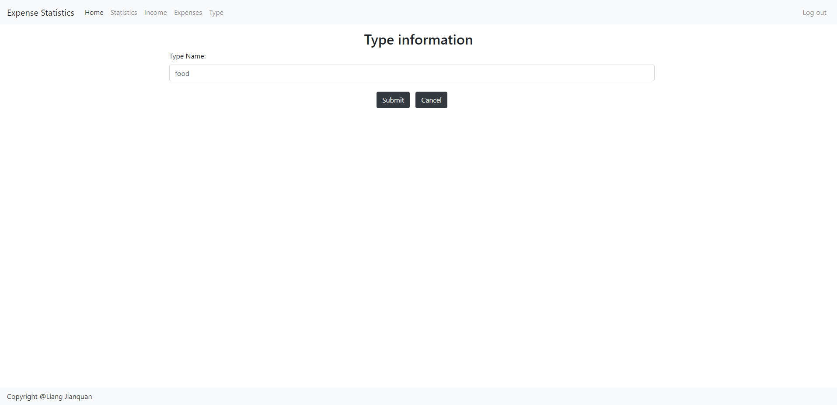

**Statistic graph page**

